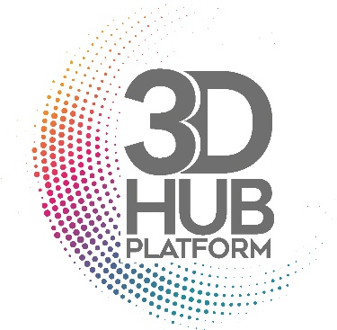

3D-Hub Matching Day
Call for oral communication

Please send your abstract by e-mail to : Laure.VERRIER@univ-amu.fr
Informations
3D-Hub plateform :
A description of the platform activity and offer is available on the Canceropôle Provence-Alpes-Côte-d’Azur website (https://canceropole-paca.com/propulser-vos-recherches/acceder-aux-technologies-expertises/)
Oral communications format for the Matching Day :
Short talk : 10 min maximum, including time for questions.

Speaker :
Name :
E-mail address :
Phone number :
Institute :
Unit :
Research team :
City :

Expertise :
Have you already used 3D-culture models for your research, or are they currently used in your group ? Oui Non
If so, which one(s) and in what scientific context (75 words max) ?

Oral communication :
Title :
Authors :
Key words :
Aim of the project :
ABSTRACT 250 words max

Are you interested in using the 3D-Hub platform for your project?
Yes
No
If so, have you already completed an application form (available here) ?

