CONTACT REQUEST FORM
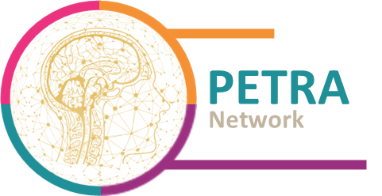
PrEclinical models and TRAnslational research in Neuro-Oncology

Date of the request: / /

General information
Academic team Regional Outside PACA
Clinical team Regional Outside PACA
Private/Industrial Company Regional Outside PACA
Name / Function:
Institution:
or Company:
E-mail:

Definition of the needs
Neuro-oncology issue:
Primary brain tumor
Cerebral metastasis
Neurotoxicity
Context (Abstract in few lines):
Project with acquired budget dedicated to service delivery: YES NO
Rational:

Objective:

Requested resources
PETRA "TECH"
Object of the study:
Cancer stem cells / Tumor cell populations
Tumor microenvironment
Tumor growth
Immune response
Tumor resection and progression
Pharmacological tests
Preclinical model needed:
3D Cellular model
Tumoroids (PDT) Explants Organotypic cultures (slides/inserts)
Spheroids (PDC) Cerebral organoids
Animal model of xenograft
Syngeneic animal model
Animal model of tumor resection
Use of the SARRP (small animal radiation research platform):
YES NO

PE"TRANSLA"
Type of study:
Translational research project
Preclinical trial
Technological project
Type of sample needed:
Fixed tissue (FFPE)
Frozen tissue
Plasma
Plasma and leukocytes
CSF
Associated data needed:
Histomolecular data
Minimum clinical data and follow-up
Imaging data

PETR"ADVICE"
Advice / orientation on a scientific project
Specify:
Expertise on a particular area
Specify:
Technological need / specific know-how
Specify:
Request for a training session on PETRA"TECH"
Specify:
Other request
Specify:

Preferred partnership
Research collaboration contract
Service contract
Occasional scientific support
Thank you for your interest in the PETRA network! Please send this completed form to: contact@petranetwork.fr
Your request is going to be evaluated by the steering committee and we will get back to you soon with a proposal meeting your needs as much as possible.

